Designing a multimedia website for the city of Skopje

A project work by Gjorgjina Cenikj

Submitted to the Faculty of computer science and engineering, June 2017

**Abstract**

This paper describes the development of a multimedia website for the city of Skopje that contains all the information a tourist might need when visiting the city. The main objective was to show the complete process of creating the website, which encompassed a number of steps including, but not limited to researching, planning, organizing, designing and coding. The whole procedure required several tools and applications, but the focus of this paper is on the coding aspect, which was realized using HTML (HyperText Markup Language), CSS (Cascading Style Sheets) and JavaScript. The result of the project is a multimedia website that successfully implements a number of techniques that are currently popular on the World Wide Web.

**Introduction**

Web design is a process of collecting ideas, aesthetically arranging and implementing them with the intention of presenting the content on electronic web pages which the end-users can access through the internet with the help of a browser.

Over the years, two opposing philosophies for web design were developed. One of them was focused on usability and the other on multimedia. The usability philosophy represents the ease of finding and processing information. One way to do this is to strip the site down to bare essentials; eliminating most if not all images and relying mainly on text to convey the message of the web site. The multimedia philosophy is on the opposite side of the design spectrum from the usability philosophy (Jackson, 2009). Multimedia refers to any electronic material that contains a combination of different types of digital content – such as text, audio, photographs, artwork, animation and video. Multimedia sites use animation, audio and video to create more interesting and interactive sites.

The website in question was supposed to present the attractions of the city of Skopje, provide information and aid in successful navigation through the city. The target audience are desktop computer users and tourists of all demographic groups.

In the process of making this website, the guidelines of several manuals were followed: "The principles of beautiful web design" by Jason Beaird, "Information Architecture for the world wide web" by Peter Morville and Louis Rosenfeld, "Research-Based Web Design & Usability Guidelines" by Michael O. Leavitt and Ben Shneiderman, and "The Website Manager’s Handbook" by Shane Diffily.

This paper continues on to describe the complete process of creating the website, starting with the required tools, gathering information, organizing the structure and content, designing the layout, and finally, the realization of the final product i.e. the coding.

**Methodology**

The website was created using HTML,CSS and Javascript.

* **HTML** (HyperText Markup Language) is the most basic building block of the Web. It describes and defines the content of a webpage. It uses 'markup' to annotate text, images, and other content for display in a Web browser.
* The Cascading Style Sheets (CSS) are used to style and describe the presentation of a document written in markup language. They are a way to manage the overall look of a publication. A style sheet controls the background, text fonts, colors, location of items, etc. (Jackson, 2009) It is usually written in a separate .css file and linked to all of the pages, thereby reducing complexity and avoiding repetition of code.
* JavaScript is a high-level, object-oriented, scripting language used to manipulate the the web page. It adds behaviors and functionality to elements in the page and even to the browser window itself. (Robbins, Learning Web Design, 2012)

Advanced web functionality (such as forms, dynamic content, and interactivity) requires web scripts and sometimes special programs and applications running behind the scenes. The programs used for the coding, designing and beautifying of this website are the following:

* Webstorm - an IDE (integrated development environment) created by JetBrains, used to facilitate the process of coding
* Adobe Photoshop - a photo editing, image creation and graphic design software, manufactured by Adobe Systems Incorporated. It provides many editing techniques, but the ones used in this projects are cropping, resizing and color correction.
* Adobe Premiere - a timeline-based video editing application developed by Adobe Systems Incorporated. It was mostly used for the purposes of color correction and adjusting the videos' size to a smaller height so they wouldn't occupy a large portion of the viewport and distract visitors from the more important content.
* WowSlider - a jQuery plugin which provides creation of image sliders with a wide variety of templates, and effects. It is practical and easy to use, since it automatically generates the engine script depending on the selected settings, so the final code is not overburdened by unnecessary data.

**THE PRE-CODING PROCESS**

The Website Design process is composed of several distinct disciplines, each of which embraces a range of skills. The sequence in which these are employed tends to follow a given pattern, encompassing the following steps:

* Information Architecture
* Interaction Design
* Interface Design
* Navigation Design
* Information Design
* Visual Design.

It should be noted that there is no clearly defined point of separation between these activities. In fact, some of them occur in parallel. (Design)

It is also important to define the target audience, which in this case were primarily the tourists that wish to visit Skopje, but since the city has experienced some major architectural projects in the last few years, it could also prove useful for locals who want to delve a bit deeper into the city's culture or discover some of the recent edifices.

**INFORMATION ARCHITECTURE AND NAVIGATION DESIGN**

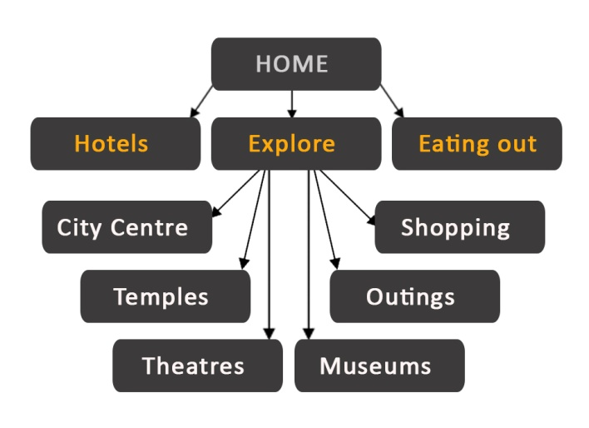Information Architecture is concerned with organising content, which is often done through site maps, diagrams or other graphical representations. A site diagram indicates the structure of the site as a whole and how individual pages relate to one another. (Robbins, Learning Web Design, 2012). As figure 1 shows, this site contains 10 pages. The menu is organized in such a way that the accommodation and eating out options are directly available, while all of the city's attractions are contained in a single drop down tab, called 'Explore', which opens when hovered.

*Figure 1 - Site diagram*

Since it is also important to give visual clues as to where the user is at any point of time, the buttons on the menu change color depending on whether the button is active or not. The inactive buttons are grey by default, while an active button uses the orange hue (with RGB value #ffab0b) that is the main color of the website to indicate the location the visitor is currently at. Each page contains 9 links to all of the other pages, except to itself, in order to prevent the visitors to waste the time needed to load the page if they accidentally click the active link.

**INTERACTION AND INTERFACE DESIGN**

The concept of usability, how easily visitors can accomplish their goals on the site, as well as the general experience of using the site, is a function of the interface design. In most cases, the interface, information archictecture, and visual design of a site are tightly entwined. (Robbins, Learning Web Design, Third Edition, 2007)

Interaction design focuses on creating engaging interfaces and includes giving users clues about behavior before actions are taken. An example of this is styling the text in such a way that all links are underlined, or the buttons change color when hovering. One of the most important aspects of interface design in general is to create consistency, because users grow accustomed to certain interface elements acting in a particular way. For this reason, the site uses previously established templates and layouts for handling the text and graphics, and are then consistently applied to build rhythm and unity across the pages.

**INFORMATION DESIGN**

Information Design is concerned with the effective presentation of content on a screen. The objective is to optimise communication by organising information in a cohesive and pleasing layout. When creating a layout, the principle output of the Designer is called a 'wireframe'. (Diffily, 2006)

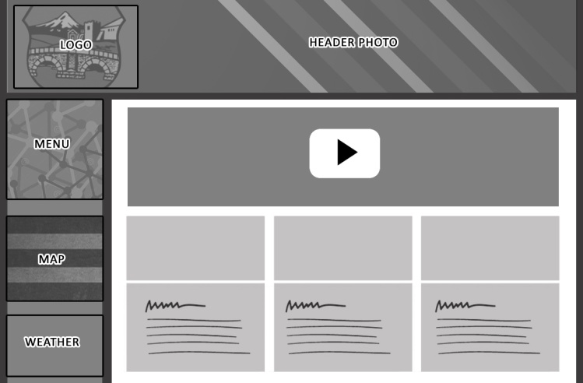A wireframe is an outline drawing of a possible arrangement of web content. It often does not contain any color or other visual elements. It simply shows where content could be placed for the purposes of good communication. . Wireframes are made before the design work is started so that the focus is on layout without the distraction of color and visual elements. They can be created using various software programs: Photoshop, Illustrator, Visio, Excel, Word, or Power Point.

*Figure 2 - Wireframe*

Figure 2 represents the wireframe for the home page of the website. Even if there’s a dramatic difference between the layout of the home page and the rest of the site, a cohesive theme or style should exist across all site pages to help hold the design together.

All of the pages have a similar layout. They have a fixed width of 1024px, while the height is flexible and adjusts itself in order to fit the content of the page, however long it may be. The top of the page is occupied by a header section of height 250px, containing the main photo featuring the name of the city and its coat of arms. The lower region is separated in 2 areas, one of them being the sidebar that contains the navigational menu and additional graphics, maps or links, depending on the page. The sidebar is realized with an aside element, has a width of 200px and is floated to the left. The other part occupies 824px horizontally, out of which 809px is the width of the actual section element containing all the main texts and articles of the pages and the remaining 15px is the margin that provides some breathing space and separates it from the sidebar.

**VISUAL DESIGN**

Since the primary target group are tourists and the World Wide Web has a great influence over the decisions a person makes when booking a holiday, it is of vital importance to make sure that the site has a wow factor that sells the city as a favorable destination.

Visual design focuses on the aesthetics and its related materials by strategically implementing colors, fonts, images and other elements. The appropriate use of color on a web page can enhance functionality or focus the user’s attention on a specific section of the page (Jackson, 2009). Contrast is defined as the juxtaposition of dissimilar graphic elements, and is the most common method used to create emphasis in a layout. The concept is simple: the greater the difference between a graphic element and its surroundings, the more that element will stand out (Beaird, 2010). This website generally uses 2 hues of grey (with RGB (red-green-blue) value #3c3b3b and #ebebeb) a vibrant orange with value #ffab0b highlight the more important elements.

**Typography**

The site implements repeating patterns of arranging text and undeviating typography to create a hierarchy that indicates the importance of each element. An orange color with RGB value orange with value #ffab0b and a font size of 20px is used to draw attention to the titles and make them stand out, while the extra information is generally 16px large and in grey. The Calibri font family is consistently used for all texts.

**Photo and video editing**

All of the graphics displayed on the website were previously edited in either Adobe Premiere, Adobe Photoshop, or both. In general, the main effects applied were resizing and color correction. The resizing can be done using the crop tool, the option Image - Image size (shortcut Ctrl+Alt+i) or creating a blank file with specific size (File-New or the shortcut Ctrl+N) and pasting the image onto it.

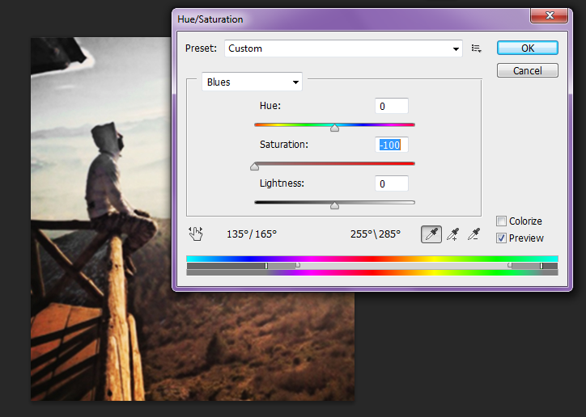There are a lot of options for color correction in the Image-Adjustments menu, but the ones used for the purposes of this project were Brightness/Contrast and Hue/Saturation, which were applied to remove the blue, cyan and magenta colors, so that the photos would not bear a striking contrast to the orange used as a main color in the rest of the website. This procedure is shown in figure 3.

*Figure 3 - Removing the blue and cyan colors using Hue/Saturation in Photoshop*

**Solution**

Repetition of colors, shapes, textures, or similar objects helps to tie a web page design together so that it feels like a cohesive unit. (Beaird, 2010) It is for this reason that the website uses the same layouts, templates and functions which are continuously repeated to organize the content. This section explains those techniques in detail, and gives them names so that they are easily distinguishable and can be referenced when used in the pages.

**THE PARALLAX EFFECT**

Parallax scrolling is a web site trend where the background content (i.e. an image) is moved at a different speed than the foreground content while scrolling (How TO - Parallax Scrolling).

As figure 4 shows, the HTML part is extremely simple and consists only of a div with class 'parallax'. The actual image is entered in the CSS, as a background image of the element. The 'background-attachment : fixed' indicates that the background is fixed with regard to the viewport and does not scroll with the rest of the page. The values of 'background-position' and 'background-repeat' make sure that the image is centered and there is no repetition. The background-size: cover scales the image to be as large as possible so that the background is completely covered.

HTML:

<**div class="parallax"**> </**div**>

CSS:

.**parallax** {**background-image**: **url**(**"img/landmarks/view.jpg"**;  
 **min-height**: 200**px**;**background-attachment**: **fixed**;  
 **background-position**: **center**;  
 **background-repeat**: **no-repeat**;  
 **background-size**: **cover**;}

*Figure 4 - HTML and CSS code for the Parallax effect*

**WEATHER WIDGET**

The weather widget might just be the simplest one to implement. All the 'behind-the-scenes' work is done by <book.net>, which makes sure that the content is accurate and regularly updated. All that needs to be done is to choose a location and design the actual look by setting color and width preferences. The weather widget is a part of all of the webpages within the website and is positioned underneath the menu and the maps.

**THE OPEN CITY FUNCTION**

The purpose of this function is to arrange lengthy pages into smaller portions of content that can be accessed through buttons. It works similarly to the tabs in a browser, except for the fact that there is a default tab named 'All', so when the page is first opened, the content of all tabs is displayed. As figure 5 shows, all buttons are of class 'tablinks', which sets the button's visual aspects like height, width, color, shadow, font size, margins and padding.

HTML:

**<button class="tablinks" onclick="** *openCity*(**event**, '**divId**')" > Title </**button**>

**<div** **id="divId"** **class="tabcontent"**>

JS:

**function** *openCity*(evt, what) {  
**var** i, tabcontent, tablinks;  
tabcontent = **document**. getElementsByClassName(**"tabcontent"**);  
**for** (i = 0; i < tabcontent.**length**; i++) { tabcontent[i].**style**.**display** = **"none"**;}  
tablinks = **document**.getElementsByClassName(**"tablinks"**);  
**for** (i = 0; i < tablinks.**length**; i++) {  
tablinks[i].**className** =  
 tablinks[i].**className**.replace(**" active"**, **""**);}  
  
**document**.getElementById(what).**style**.**display** = **"block"**;  
evt.**currentTarget**.**className** += **" active"**;}

Each button is connected to a single div of class 'tabcontent' that contains the content that is supposed to be hidden or shown when the button is active. These divs have a unique id that is used as the second argument when the function is called.

Once inside the function, first the variables 'i', 'tabcontent' and 'tablinks' are declared.

Then, the function finds all the elements of class 'tabcontent' and hides them by setting their display property to 'none'.

Next, it iterates through the 'tablinks' and removes the class 'active' from the element that was previously selected.

Finally, it shows the div connected to the id passed as an argument to the function by changing its display property to 'block', and adds the 'active' value to the currently selected button.

*Figure 5- The HTML and JS of the OpenCity function*

**GOOGLE STREET VIEW**

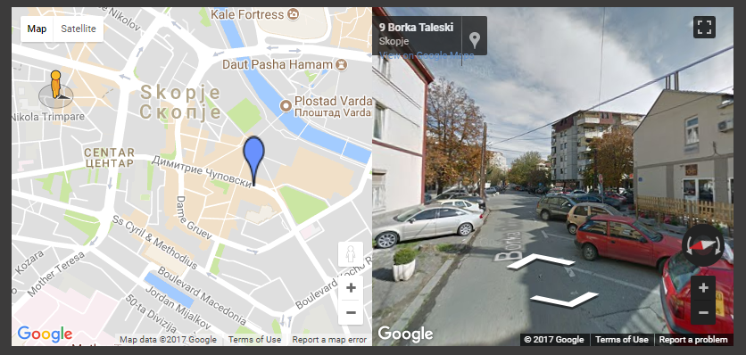Google is quite generous with its resources. Not only does it allow everyone to use their various maps under a Creative Commons Attribution license, it also provides the code samples for various styles of presentation, licensed under an Apache 2.0 license, so it's extremely simple to embed them on websites. All that needs to be done is set the coordinates and the API key. This site uses the codes for the basic and side-by-side street view, a preview of which is shown on figure 6, obtained on the [Google Street View service.](https://developers.google.com/maps/documentation/javascript/examples/streetview-simple?hl=Es)

*Figure 6 - The side-by-side google street view*

**MULTIPLE LOCATION MAPS**

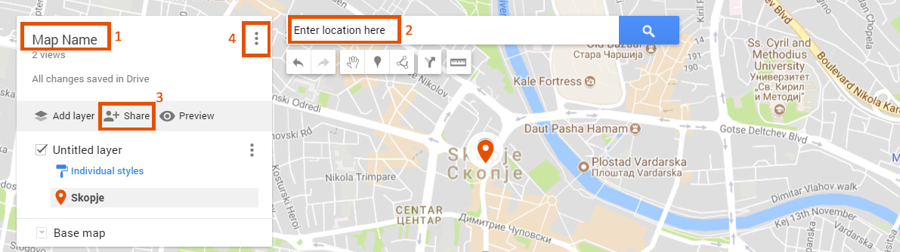The site uses Google Maps to generate all of the maps and plot the locations pins on it. Figure 7 gives a general idea of each step of the process, which is done by signing into a Google account, going to https://www.google.com/maps, opening the menu, selecting 'Your Places', then clicking the 'Maps' button on the outmost right, and finally, selecting 'Create map' at the bottom of the menu.

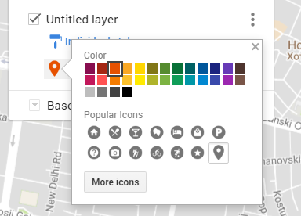Once the new tab opens, the name and default view of the map can be set. It is now possible to pinpoint locations manually by clicking the marker icon and placing it directly onto the map, or search for locations using the search box at the top of the screen. If you're searching and adding specific locations, a green marker will appear on the map and you can click the 'Add to map' link.

*Figure 7 - An implementation guide for Google maps*

It is also possible to select different map styles, different pin colors and icons. This is done through the options represented on figure 8. All of the pins used for this site are orange colored (RGB value 230,81,0), but they have different icons depending on the type of object that they represent (hotel, restaurant, church etc.)

*Figure 8- Pin styling*

Once all of the locations are added, the map should be embedded on the site. To do this, it is of vital importance to make sure that the map is public. This can be done by clicking the 'Share' button beneath the map name, and changing the 'Who has access' value from the default 'Private - only you can access' to 'On - Public on the web', and saving the settings. The final step is to generate the code for the map, which is done by clicking the menu icon next to the name of the map and selecting 'Embed on my site'. This produces the final code which is just copied and pasted into the desired place in the HTML document.

**GOOGLE CALENDAR**  
The calendar on the 'Hotels' page is implemented by following the [Google Calendar](https://calendar.google.com/calendar/render#main_7) manual, which is extremely simple and only requires the user to create a calendar or select an already existing one, make it public and get the iframe code by clicking 'embed this calendar'.

**THE ZOOM-IN GALLERY**

The zoom-in gallery is a simple way of displaying a group of photos in such a way that when the visitor hovers the cursor over one of the photos, it enlarges and offers a better view. Figure 9 shows how it can be applied to work with 3 images of width 150px and height 100px, but with some adjustments and careful mathematic calculations, the gallery can be easily customized for any number of photos and any sizes.

CSS:

.**gallery** {  
 **width**: 485**px**;  
 **background-color**: **#c5bebe**;  
 **padding**: 4**px**;  
 **box-shadow**: 0 1**px** 2**px**

**rgba**(0,0,0,.3);  
 **float**: **left**;  
 **margin-right**:4**px**;  
 **margin-left**: 3**px**;}  
  
.**gallery** > **div** {  
 **position**: **relative**;  
 **float**: **left**;  
 **padding**: 4**px**;}  
  
.**gallery** > **div** > **img** {  
 **display**: **block**;  
 **width**: 150**px**;  
 **transition**: .1**s transform**;  
 **transform**: **translateZ**(0); **height**: 100**px**;}

.**gallery** > **div**:**hover** {  
 **z-index**: 1;}  
  
.**gallery** > **div**:**hover** > **img** {  
 **transform**: **scale**(1.7,1.7);  
 **transition**: .3s **transform**;}

The gallery class and the divs inside of it simply act as a containers for the images, and set their padding and margins.

The transform: translateZ(tz) property in the .gallery > div > img selector is a shorthand for translate3d (0,0,tz), and moves the element along the z-axis of the 3D space. In the case of translateZ(0), prevents the movement in z direction.

The transition makes the element change smoothly and gradually from the first to the second state.

The z-index property specifies the stack order an element, in such a way that an element with greater stack order is in front of an element with a lower stack order. In this case, it enables the hovered photo to go in front of the rest of the gallery.

The transform : scale property defines a 2d scale proportional transformation (1.7,1.7) with a transition with 0.3s duration.

*Figure 9 - The CSS of the Zoom-In gallery*

**THE FANCYBOX GALLERY**

FancyBox is a tool for displaying images, html content and multi-media in a Mac-style “lightbox” that floats on a page. (Fancybox - Fancy jQuery) The photo viewer has been implemented using the jQuery library, it uses screen resolution detection to sit the image popup in the center of the screen, a soft fade effect and also chevron icons for navigation. (Cimo, 2015) FancyBox is licensed under Creative Commons Attribution license, and is free to use for personal or non-profit projects. There are a lot of easy adjustments that can be made to it. The gallery used for the purposes of this website is a simplified version that does not use the mouse wheel plug-in and does not contain any extra information. It is only meant to provide a better view of the photos.

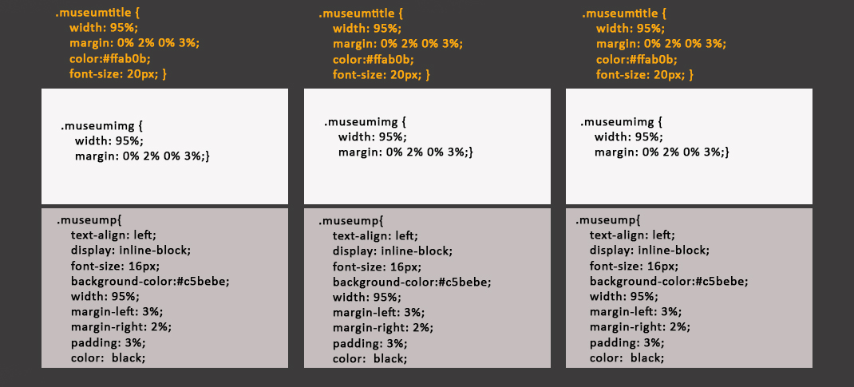**THE THREE COLUMN TEMPLATE**

*Figure 10 - The layout and CSS code for the Three-column template*

Figure 10 shows the 'three column template', which enables the division of a row into 3 cells, each containing the name of an institution, a photo, and a short text. This is achieved by creating 3 span elements of class 'museum' with a width of 267px, each of which contains a span of class 'museumtitle' for the title of the institution, a photo of class 'museumimg' for the photo and a span of class 'museump' for the description of the institution. All of them have the same values for the width - 95%, leaving 5% for the margins. The 'museump' span has a padding of 3%, creating a decent gap between the edge of the container and the text. The title has a size of 20px and an orange font color of value #ffab0b, while the description has a size of 16px and a black font color. It is important for the images to be of the same size (or at least have the same width-height proportion and be scaled appropriately) in order to obtain a symmetric look.

**THE HALFLING TEMPLATE**

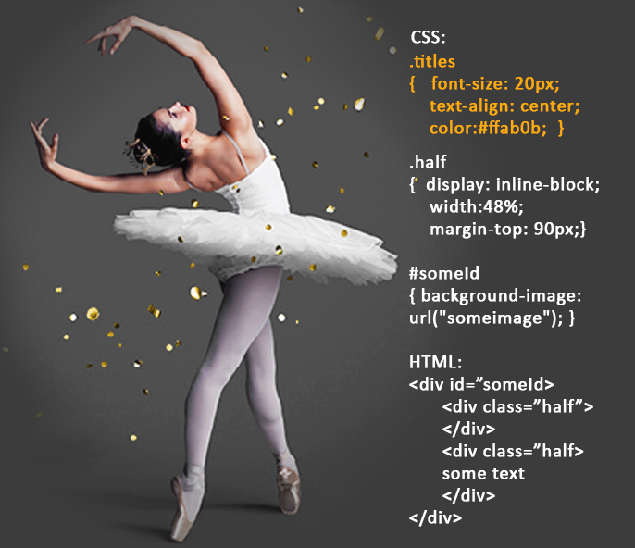The template is composed of 3 divs, the first of which acts as a container for the other two and features a background image. Figure 11 shows an example. The photo has to be carefully edited so that it blends in nicely with the color of the website. Inside of this div are 2 divs of class 'half' which have an 'inline-block' display and a width of roughly half the size of the website. The first div is empty and serves simply to aid the positioning of the second one, which contains the text.

*Figure 11- An example of the halfling template, along with the HTML and CSS code*

**IMPLEMENTATION**

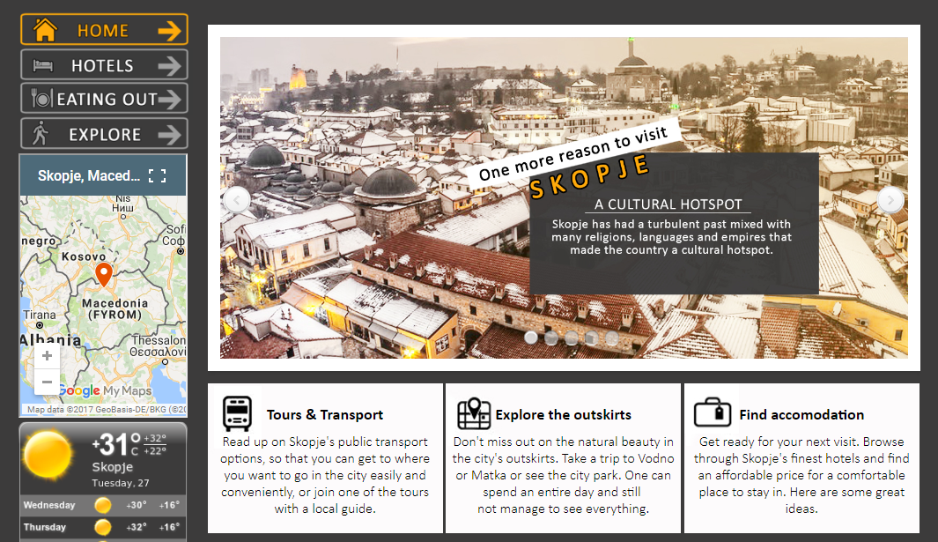This section presents the implementation of the different methodology into the actual pages, describing where each template, layout or function were used.

**1.'Home'**

The homepage is relatively short and effective, emphasizing the site's key features. Figure 12 shows a preview, which starts off by representing 5 reasons to visit the city, each one linking to an appropriate section of the website. This is implemented with a WOW slider, using a 'calm' template and a 'basic' transition effect. It is set to auto play and uses both bullets and previous/next buttons for navigation.

*Figure 12-The home page content*

The area below it is divided into 3 columns, each one proposing an action - to go to the hotels, outings or explore pages. The icons next to the title of each columns are in fact part of the background which is edited in Photoshop to be of appropriate size and positioning of the icon.

This is followed by a video representing some of Skopje's most spectacular sights. The video, courtesy of Macedonia Timeless, it is set to auto play but it is muted by default. The rest of the page is fairly simple and provides some extra information about the city.

**2. 'Hotels'**

This page features the top 12 hotels in the city, each represented with a 3-image gallery, title, ratings, contact information and price. The titles contain a link to the hotels' official website. The photos are implemented with the WOW Slider application, using the Convex template with automatic fade effect with 2 seconds delay and a bullet list for navigation between the photos, positioned at the bottom of the gallery. It contains a google calendar that is meant to be of use for the visitor when planning the holiday and the number of nights spent in the hotel.

**3. 'Eating out'**

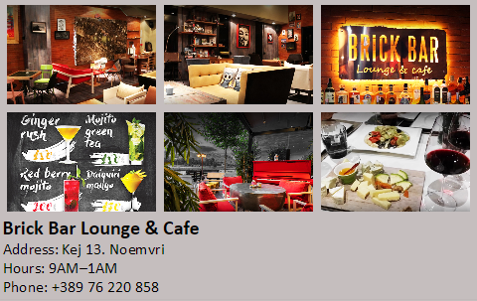The eating out page contains 40 popular restaurants in the city, sorted using the OpenCity function into 4 categories: 'Cafe', 'Dining', 'Fast Food & Pizza' and 'Pastries'. Each restaurant is represented with its name, containing a link to the official site, address, phone and working hours. Additionally, there is one zoom-in gallery, like the one depicted on figure 13, for each restaurant which is modified to fit 6 images into 2 rows and 3 columns.

*Figure 13- Modification of the zoom-in gallery*

**4.'Explore'**

The explore page is used to give the visitor a general idea of everything there is to see and do in Skopje. It contains a preview of the most popular tourist attractions, realized with a WOW slider. The page is meant to provide useful information for getting in and around the city by presenting all of the available transporting options, and gives the opportunity to explore the city via the side by side version of Google Street View, that enables the viewer to see the location he is currently at on a map while he is moving through the street view. It also displays some of the more popular tours in the city using the Three-column template and provides a link to a website that enables booking tickets for the tour.

**5.'City centre'**

The 'City centre' page presents the most popular tourist attractions located near the city centre. For this purpose, 3 tabs are created: 'Macedonia Square', 'The Old Town' and 'Historical Heritage', which are controlled by the OpenCity function in the script file.

The content of each of the tabs starts off with a div with a height of 344px and a width of 809px, and a background image featuring the City Square, the Old Bazaar, or the Kale Fortress, accordingly. Inside of this div, there is another one of width 400px that contains the text that is positioned above the photo using top and left margins.

The 'Macedonia Square' tab continues to present the city square and some of the landmarks situated in its proximity, all of which have the same layout: a paragraph of class 'titles', followed by a paragraph of class 'info', followed by a div of class 'rowgallery', which is essentially, the zoom-in gallery modified to fit 5 photos of width 157px in one row. This is done by increasing the width of the gallery container to 809px, instead of its usual 400px, and adjusting the width of the photos and the passing according to personal preference. The page also contains a video that displays the city centre in all its glory. The video is set to play automatically, without audio (muted), and displays the control bar on hover.

'The Old Town' tab also applies a 'rowgallery', but it also makes use of the parallax effect to present some extra photos of the Old Bazaar. The buildings and bigger attractions of the Bazaar, like the Clock Tower, the hans and the hamams are shown with the three column template. There are also 2 videos about the bazaar and one of the hans that are not set to auto play but instead display a poster image until the user chooses to start the video.

The 'Historical Heritage' tab includes the Kale Fortress and the Skopje Aqueduct. The additional text for the Kale is situated in between two photos, which is achieved by simply by positioning the photos into span containers with inline display and setting their width to 230px each, so that when they are summed up with the text container with width 310px and the margins, they would not exceed the page width which is 809px. The photos can be viewed with the fancybox gallery. Much like the 'Macedonia Square' tab, there is a muted video set to autoplay, just to add some dynamic to the page and show more of the Kale Fortress. The article about the Skopje Aqueduct is realized with a background image and a text container positioned directly above it.

**6.'Temples'**

The larger part of this page is occupied by an image slider displaying the churches in the proximity of Skopje. The slider was made with some color adjustments to the Convex Template of the WOW Slider, making use of the book transition effect and adding options for navigation which can be done through the previous/next buttons or the bullet navigation at the bottom of the slider.

The mosques are displayed with the three column template.

**7.'Theatres'**

The page uses the OpenCity function to navigate through the different types of theaters, which are divided into three tabs: Drama Theaters, Opera & Ballet, and Cinemas. The 'Drama Theaters' tab starts off with a virtual tour of The Macedonian National Theatre, which is a courtesy of their [official website](http://www.mnt.com.mk). The tour is implemented with an iframe tag with the source element connecting it to the site and an id 'mnttour' which sets the width and height.

The rest of the theaters are presented with a title of class 'titles' and extra information of class 'info', which set the color, size and alignment of the text. The photos are all of width 197px, and can be previewed with the fancybox gallery. The theaters are also separated with a horizontal line, and each of them contains a link to the official site of the theatre.

The upper part of the 'Opera & Ballet' tab is realized with the halfling template.The tab also contains three videos of the Macedonian opera and ballet ensemble, which were previously edited in Adobe Premiere to suit the orange&grey coloring of the website and shrink them to an appropriate size. The 'Cinemas' tab is rather simple and is implemented with the three column template. It contains the contact info for each movie theatre and a link to their official website.

**8.'Museums'**

The museums page relies entirely on the three column template. It also makes use of the fancybox gallery to view the images, while the title contains a link to the institutions' official site, or a site that provides extra information for the ones that don't have one.

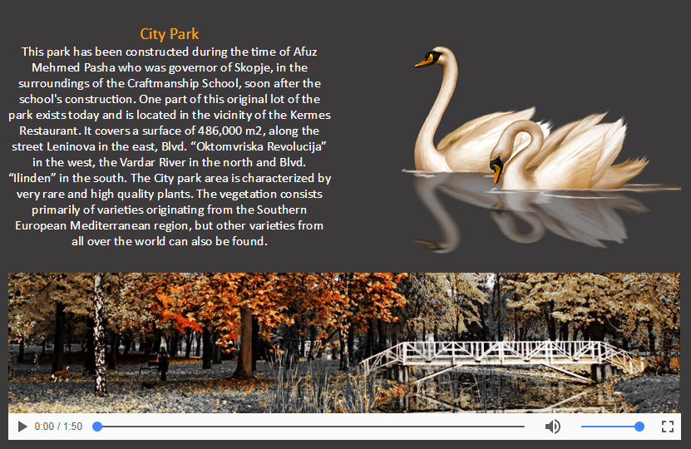**9.'Outings'**

The Outings page uses the halfling template to present the city park and zoo. Each of them is followed by a video which is was previously edited in Adobe Premiere to set a lower height so they don't occupy a large portion of the viewport and discourage the visitors from scrolling downwards to see the rest of the content. A preview is shown on figure 14.

*Figure 14-The section representing the city park*

The videos are not set to auto play and instead contain a poster photo that is displayed until the user chooses to start the video by clicking the play button. The poster photos are edited so they match the size of the video and fit in nicely with the colors of the website.

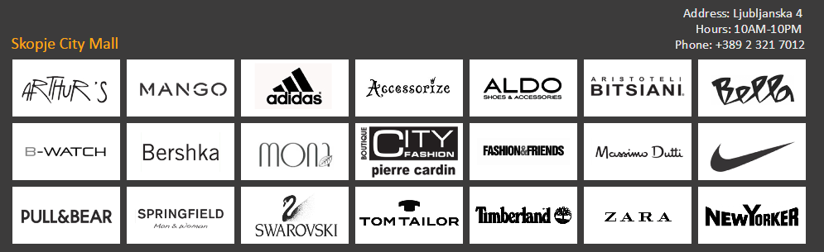The article about the Matka canyon has a video background which is enabled through careful CSS styling, and it is meant to add some dynamic to the page. The div with id 'videoDiv' only acts as a container and sets the width and height, while the div containing the extra information has a white color and a text shadow to make it more easily readable. The opacity of the video is decreased to 20%, for the previously stated reason. The same video is positioned right above the text and set to auto play.

*Figure 15-An implementation of the zoom-in gallery for the stores in a shopping mall*

**10.'Shopping'**

The shopping page displays the 4 most attractive shopping centers in the city, featuring their most popular brands in a zoom-in gallery, where each logo contains a link to the appropriate store. An example is shown on figure 15.

**Results**

All of the steps that have been explained result in the creation of a cross platform, browser compatible website with consistent layout, logical and prominent navigation. It follows the basic principles of graphic, information, navigation and interface design, and satisfies the requirements of a multimedia website, containing a combination of text, photos, videos, and animation.

It uses a variety of attractive graphics and carefully edited, matching photos and videos to not only capture and hold the users' attention, but also to dazzle them and make them want to visit the city. It uses consistent design and typography to create hierarchies and highlight the most important aspects. It contains just the right amount of details to keep the visitor interested but not scare them away, and provides appropriate links to the official sites for those who want to learn more.

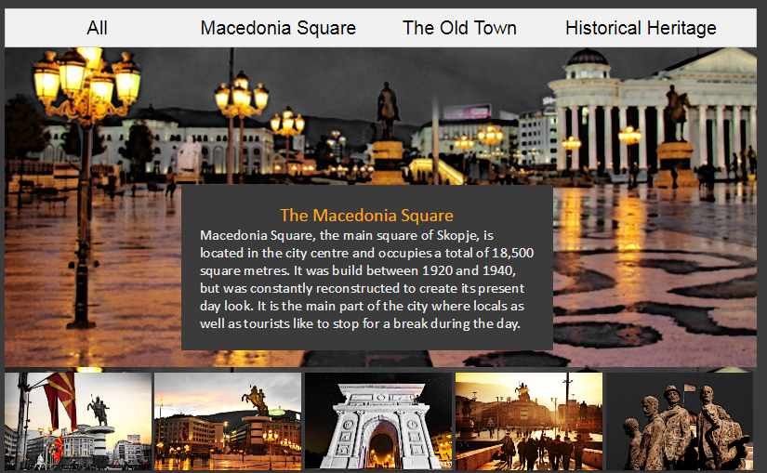

*Figure 16*

It is catered to the tourists' needs, and provides all the information that might aid them in navigating through the city, including maps, street views, weather forecast, transport schedules, accommodation suggestions, and tours.

**Discussion**

The aim of the project was to create a 10-page multimedia website about the city of Skopje. A variety of contemporary techniques and methods were implemented in order to pack all of the information in the limited amount of space, and still obtain an attractive and eye-pleasing design. However, there are some things that could enhance the performance and usability of the website.

According to [W3Schools data](https://www.w3schools.com/browsers/browsers_display.asp) from January 2017, about 95% of the users have a screen resolution of at least 1024x768 pixels. This means that the website's fixed width of 1024px should work nicely on almost all desktop and laptop devices. It might be preferable for the website to use a fluid layout that stretches and adapts to the user's window size, even though according to recent statistics, only 2 of the top 10 websites worldwide use a truly fluid layout (Google and Wikipedia).

The major setback of this website is that it's not mobile-friendly. Even if we overlook the fact that mobile users would have to put in some extra work to see the whole content, there's still the issue that in April 2015, Google announced that it will be moving to a mobile-first index, meaning that it will rank results based on the mobile friendliness even for desktop searchers and this kind of site would probably not rank high in the search listings.

High quality graphics and fancy plug-ins come at a price, one of them being the loading time, which also directly affects the web traffic and ranking. Even though some basic effort has been put into this aspect of the design, like cropping the unnecessary parts of the images, changing the resolution and compressing them, there are still things that can improve the loading time. Some of them include lazy loading the images, minifying the code, caching, and optimally ordering the components of the page.

One of the improvements that can be made in the future is to add more choices of accommodation, more details about the hotels and apply a sorting algorithm that could arrange them based on ratings, price, proximity etc. Another idea was the embedding of reviews for each of the tourist destinations, but it was left unimplemented because of the lack of space, the limitation to using 10 pages, and the possible drastic increase in the loading time.

To sum up, even though the website is fully functioning as it is, there is a lot of place for improvement. The biggest challenge of all, however, is keeping up with the latest technology and ever-changing trends on the World Wide Web.

# Works Cited

Beaird, J. (2010). *The Principles of Beautiful Web Design.* Ottawa: SitePoint Pty Ltd.

Cimo, F. (2015, May 5). *HTML5 Photo Gallery Example*. Retrieved June 10, 2017, from Web Code Geeks: https://www.webcodegeeks.com/html5/html5-photo-gallery-example/

*Designing*. (n.d.). Retrieved June 24, 2017, from Max Design.

Diffily, S. (2006). *The Website Manager’s Handbook .* Morrisville : Lulu.

*Fancybox - Fancy jQuery*. (n.d.). Retrieved June 10, 2017, from Fancybox: http://fancybox.net/

*How TO - Parallax Scrolling*. (n.d.). Retrieved June 15, 2017, from W3Schools: https://www.w3schools.com/howto/howto_css_parallax.asp

Jackson, L. D. Intorduction to the internet and web page design. *Intorduction to the internet and web page design.* Faculty of the Communication Department, Cedar City.

Robbins, J. N. (2012). *Learning Web Design.* Sebastopol: O’Reilly Media.

Robbins, J. N. (2007). *Learning Web Design, Third Edition.* Sebastopol: O’Reilly Media.